TOMCAT INSTALLATION AND CONFIGURATION ON AWS EC2

1. Launch a redhat linux server
2. Install Java

* #yum install java-1.8* -y

check point

* java -version

1. Install Apache Tomcat

Get the package from apache website:

<https://tomcat.apache.org/download-80.cgi>

Go to /opt folder

#cd /opt

#wget <https://mirrors.estointernet.in/apache/tomcat/tomcat-8/v8.5.69/bin/apache-tomcat-8.5.69.tar.gz>

#ls

#tar -xvzf /opt/apache-tomcat-8.5.54.tar.gz

1. Give executing permissions to startup.sh and shutdown.sh which are under bin

#cd bin

#chmod +x /opt/apache-tomcat-8.5.54/bin/startup.sh

#chmod +x /opt/apache-tomcat-8.5.54/bin/shutdown.sh

**Checkpoints**

Access tomcat application from browser on port 8080

http://<Public_IP>:8080

1. Change the port number in conf/server.xml file under tomcat home

# cd /opt/apache-tomcat-8.5.54/conf

# update port number in the “connecter port” field in server.xml

# re-start tomcat after configuration update

**<Connector port="8080" protocol="HTTP/1.1"**

**connectionTimeout="20000"**

**redirectPort="8443" />**

**Note:** By default, port number is 8080

**Checkpoints**

Access tomcat application from browser on port 8080

http://<Public_IP>:8080

6.Search for context.xml file

#find / -name context.xml

Above command gives 3 context.xml files. Comment ()ValueClassNamefield on files which are under webapp directory. After that restart tomcat services to effect these changes

/opt/apache-tomcat-8.5.69/webapps/host-manager/META-INF/context.xml

***<!-- <Valve className="org.apache.catalina.valves.RemoteAddrValve"***

***allow="127\.\d+\.\d+\.\d+|::1|0:0:0:0:0:0:0:1" /> -->***

/opt/apache-tomcat-8.5.69/webapps/manager/META-INF/context.xml

***<!-- <Valve className="org.apache.catalina.valves.RemoteAddrValve"***

***allow="127\.\d+\.\d+\.\d+|::1|0:0:0:0:0:0:0:1" /> -->***

1. update users information in the tomcat-users.xml file, go to Tomcat home directory and add below users to conf/tomcat-user.xml file

***<user username="admin" password="admin" roles="manager-script,manager-status,manager-gui"/>***

1. We need to enable security Group in AWS instance

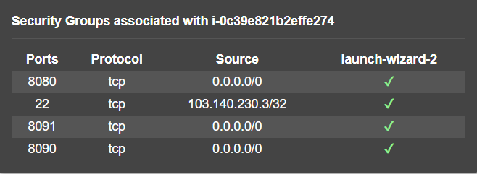

1. Restart service and try to login to tomcat application from the browser.